ELASTIC SERACH INSTALLATION DOCUMENT

Step 1: Download the Elastic search engine zip file from the below link

<https://www.elastic.co/downloads/elasticsearch>

Version: 2.4.1

Step 2: Unzip the package. Set “JAVA_HOME” system variable with the Java JDK home path.

Eg. C:\Program Files\Java\jdk1.8.0_74

Step 3: Change the configuration property file for Elastic search (elasticsearch.yml) present in the config folder path

Eg. ..\elasticsearch-2.4.1\ config

The properties to be uncommented/modified in the elasticsearch.yml file are as follows

1. **cluster.name**: my-application
2. **node.name**: node-1
3. **bootstrap.memory_lock**: true
4. **http.port**: 9200

Step 4: Start the ElasticSearch server by running the “elasticsearch” file present in the bin directory.

Eg. ..\elasticsearch-2.4.1\bin

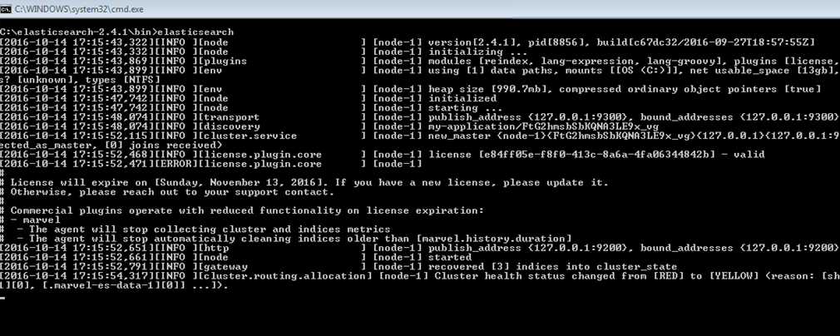

Test if the server got started by entering the following URL: http://localhost:9200/

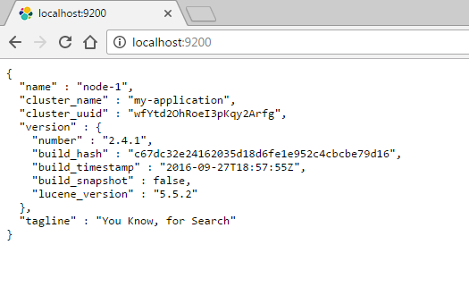

Step 5: Install “Sense” plugin extension for chrome. You can find that in the following URL

<https://chrome.google.com/webstore/detail/sense-beta/lhjgkmllcaadmopgmanpapmpjgmfcfig?hl=en>

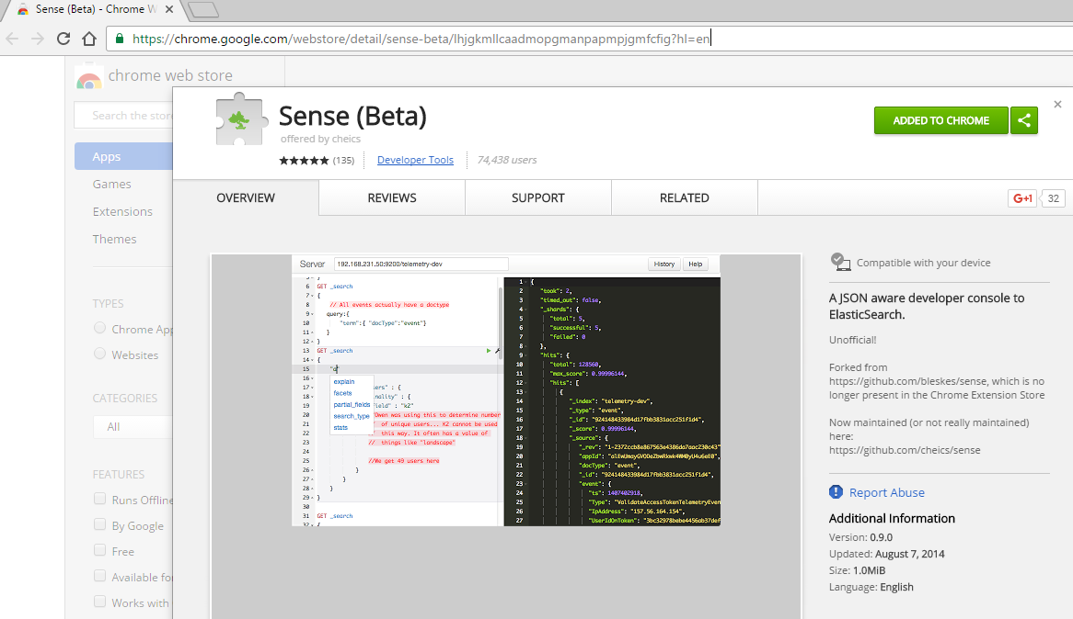

The sense plugin can be accessed by clicking on the sense icon on the top right corner.



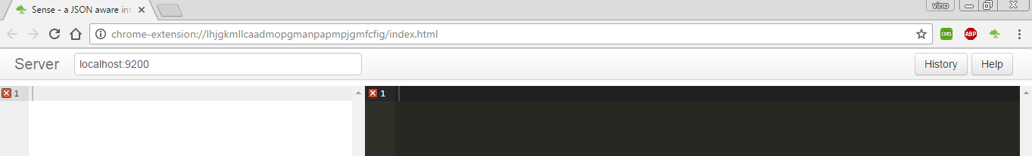

Step 6: We are now set. We can continue our CRUD operations using the “sense” console.